## **Fertilizers Recommendation System For Disease Prediction**

Name : Subashini SL

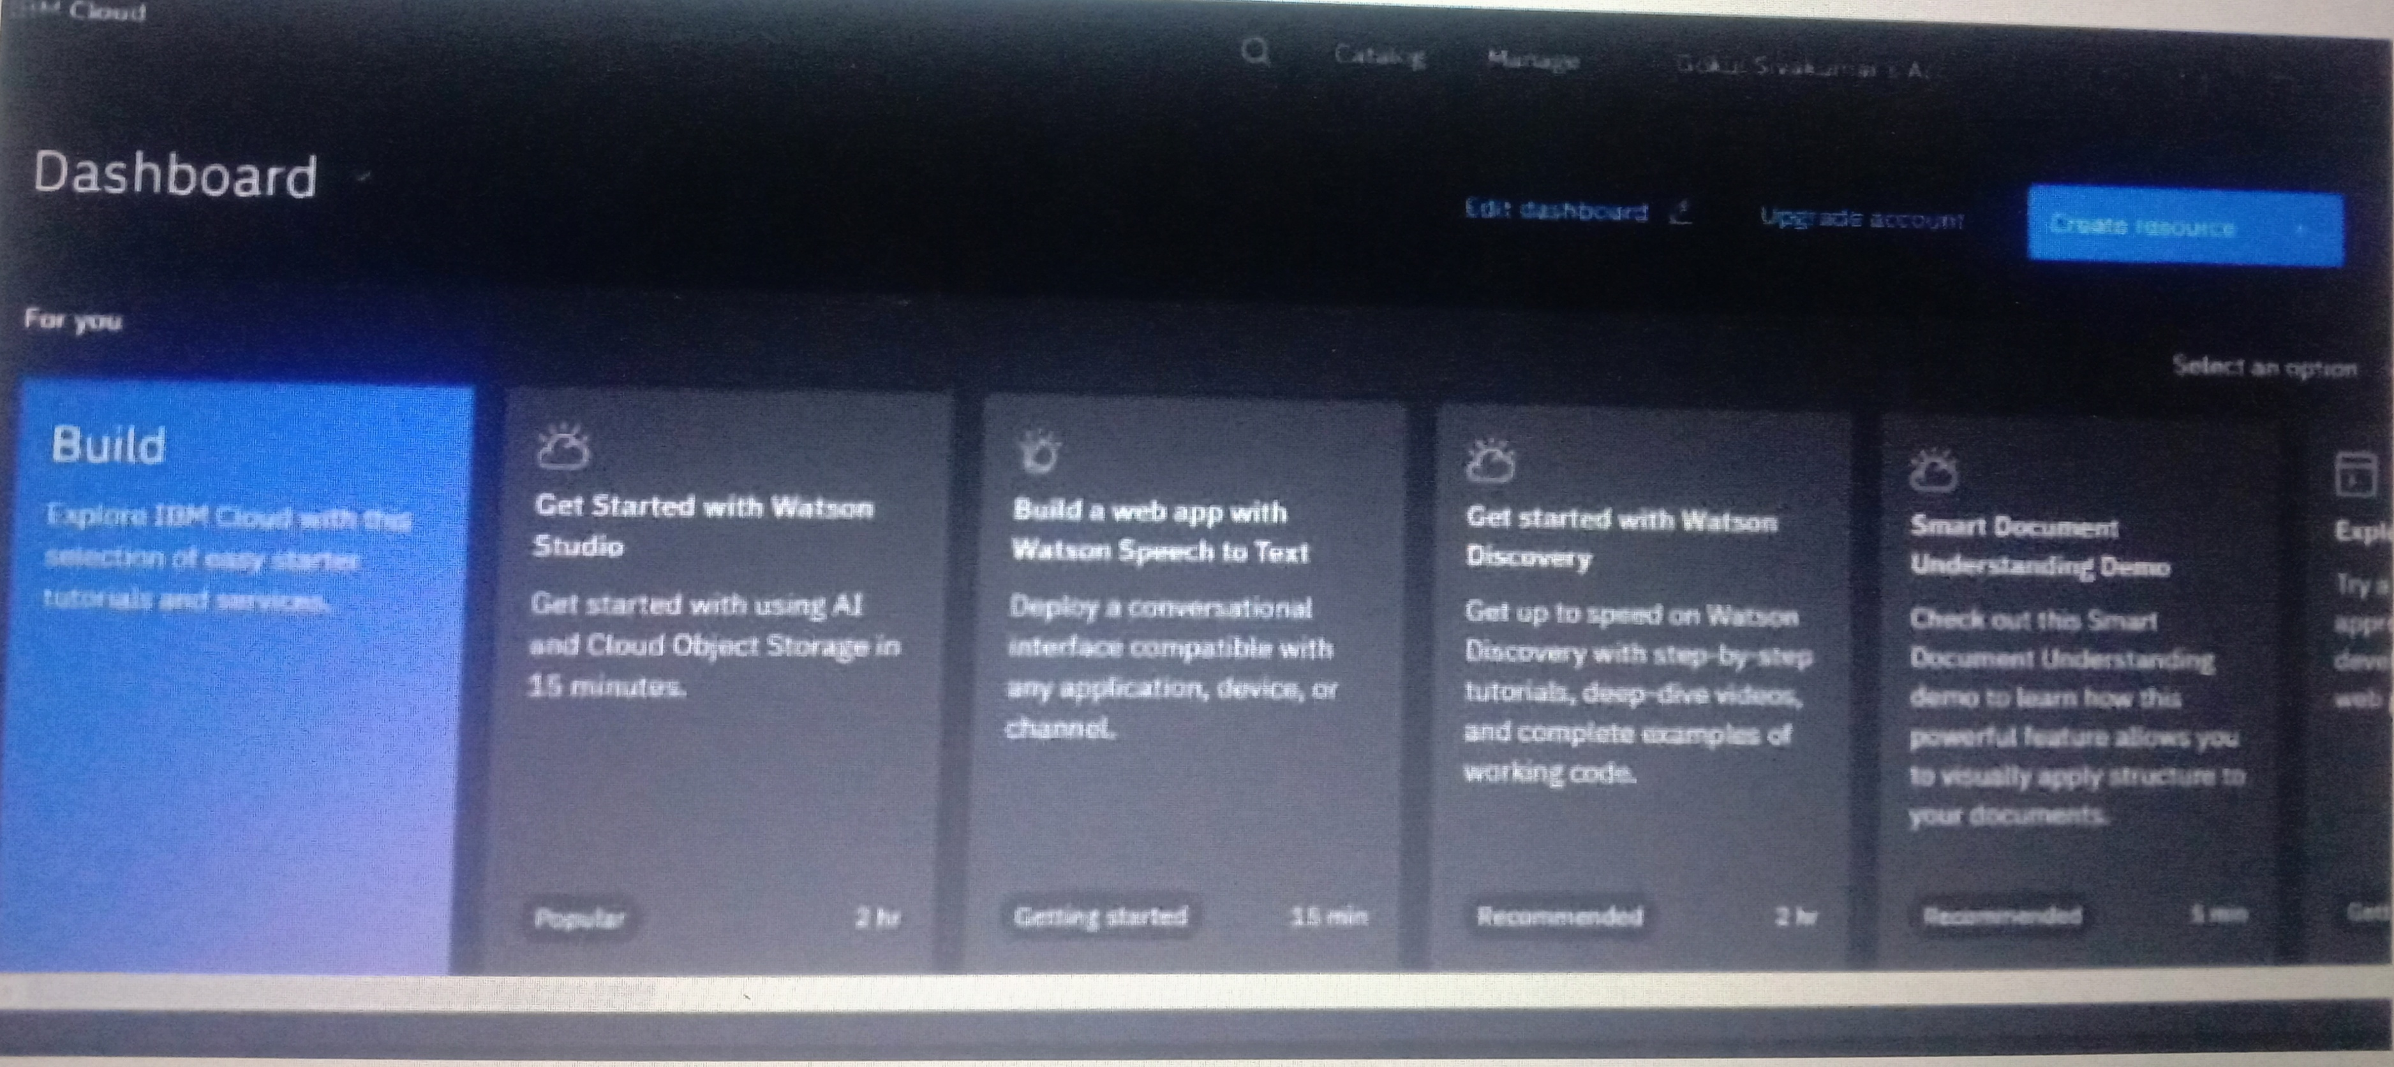

Name : Kavilaiya V

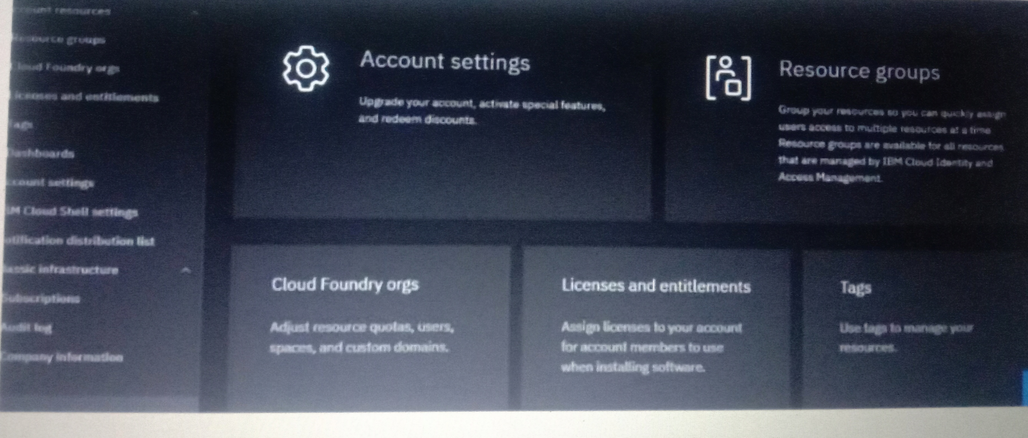

Name : Yamini R



Name : Komathi M

